# Exercise #1: Simple Bank

[Please follow this link to access the Simple Bank exercise on GitHub.](https://classroom.github.com/a/r6Ichc_V) This link will ask you to clone the assignment into the classroom repository in GitHub classroom.

We use [Github Actions](https://github.com/features/actions) to automatically check your assignments. Actions will run ganache-cli on port 8545 to run the tests, so make sure that your assignment is running on that port when you submit the final version.

We have written a few tests for the smart contract that will run whenever you update your code on GitHub. [You can see the tests here.](https://github.com/ConsenSys-Academy/simple-bank-exercise/blob/master/test/simpleBank.test.js) We'll be walking through how to complete both this exercise and the next in the live lesson "Introduction to Smart Contract Exercises" on **September 28th, 2021**. A recording of that session will be available afterwards. In the meanwhile, you can ask questions in the Discord channel for the "smart contract" section.

By looking at the Github repository, you can see whether or not the tests pass. Below, you can see an example of the assignment repository passing all its tests:

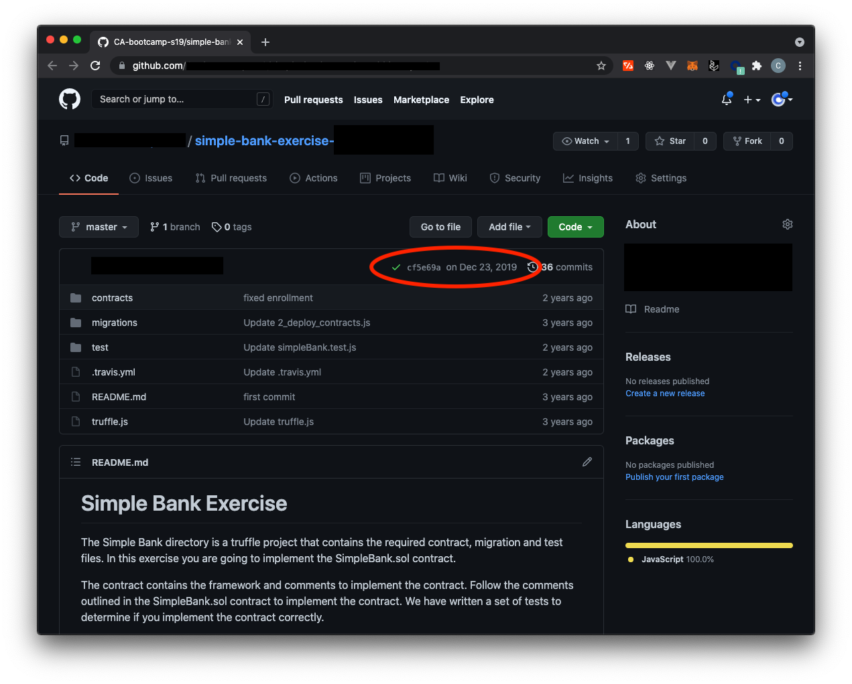

Here's an example of an assignment repository not passing its tests:

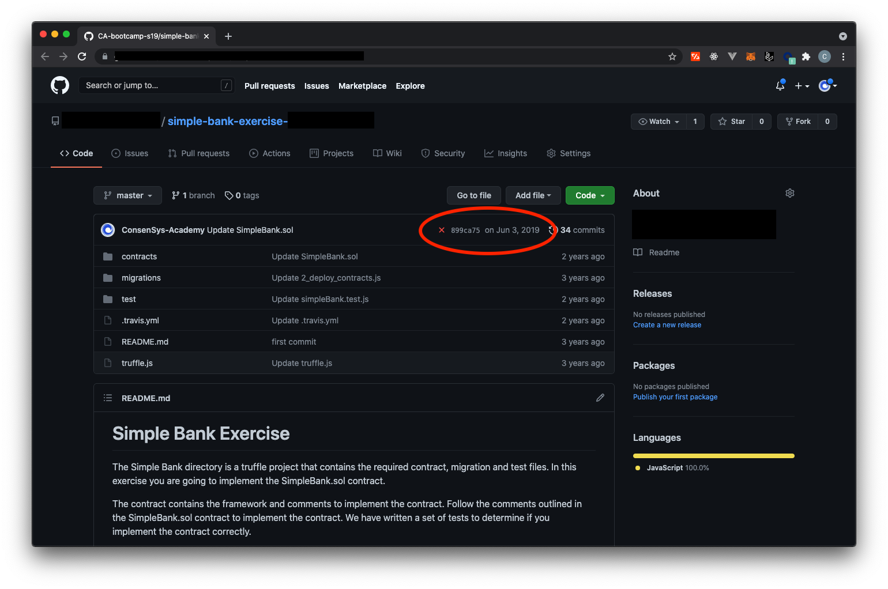

### Workflow for completing the assignment

1. [Click on the assignment link](https://classroom.github.com/a/r6Ichc_V) to create your own assignment Github repository
2. Clone the repository to your local computer and complete the smart contract code. [Follow these instructions](https://github.com/ConsenSys-Academy/simple-bank-exercise#instructions) so all your tests pass when you run truffle test
3. Commit your smart contract work to the repository locally and [push](https://www.atlassian.com/git/tutorials/syncing/git-push) it to your own assignment repository on Github
4. Check your repository on Github to make sure you see a green check for your tests passing on Github.

Good luck!

# Exercise #2: Supply Chain

[Please follow this link to access the Supply Chain exercise on GitHub.](https://classroom.github.com/a/O-yrYqWz) This link will ask you to clone the assignment into the classroom repository in GitHub classroom.

If you are having trouble accessing the assignment, please reach out on Discord.

We use [Github Actions](https://github.com/features/actions) to automatically check your assignments. Actions will run ganache-cli on port 8545 to run the tests, so make sure that your assignment is running on that port when you submit the final version.

We have written a few tests for the smart contract that will run whenever update your code on GitHub. [You can see the tests here.](https://github.com/ConsenSys-Academy/simple-bank-exercise/blob/master/test/simpleBank.test.js) We'll be walking through how to complete both this exercise and the next in the live lesson "Introduction to Smart Contract Exercises" on **September 28th, 2021**. A recording of that session will be available afterwards. In the meanwhile, you can ask questions in the Discord channel for the "smart contract" section.

By looking at the Github repository, you can see whether or not the tests pass. Below, you can see an example of the assignment repository passing all its tests:



Here's an example of an assignment repository not passing its tests:



**NOTE: When your submission passes all of the tests, you will receive credit for the assignment.**

### Workflow for completing the assignment

1. [Click on the assignment link](https://classroom.github.com/a/O-yrYqWz) to clone the assignment to your own Github repository
2. Pull the repository to your local computer and complete the smart contract code. [Follow these instructions](https://github.com/ConsenSys-Academy/simple-bank-exercise#instructions) so all your tests pass when you run truffle test
3. Commit your smart contract work to the repository locally and [push](https://www.atlassian.com/git/tutorials/syncing/git-push) it to your forked repository on Github
4. Check your repository on Github to make sure you see a green check for your tests passing on Github.

Good luck!